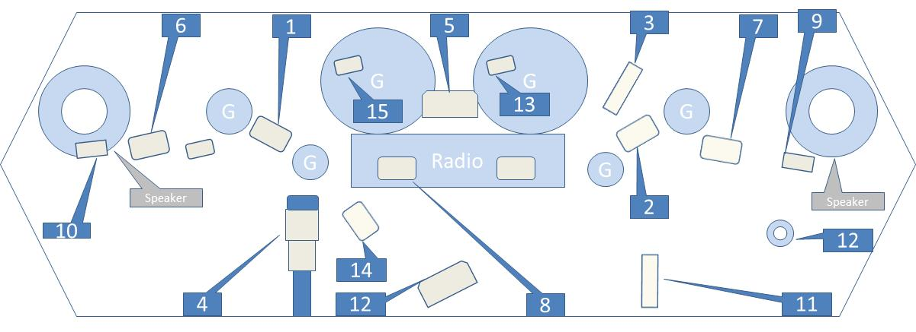
1. Main to interconnect harness (1)
2. Main to interconnect harness (2)
3. Audio to interconnect harness (6)
4. Main to interconnect harness (15)
5. Indicator lights
6. Right handlebar switches
7. Left handlebar switches
8. Radio (27)

9. Left front turn signal/auxiliary lamp (31L)
10. Right front turn signal/auxiliary lamp (31R)
11. Front fender tip lamp (32)
12. Headlamp (38)
13. Speedometer gauge (39)
14. Fairing cap switches (105)
15. Tachometer gauge (108)
16. Cigarette lighter

