PV Tuner Basic Instructions version 1.13
1. Check for Firmware update. Connect your Power Vision unit to your computer, open the update client and make sure you have the latest firmware. PV Log tuner requires version 1.0.3-723 or later firmware

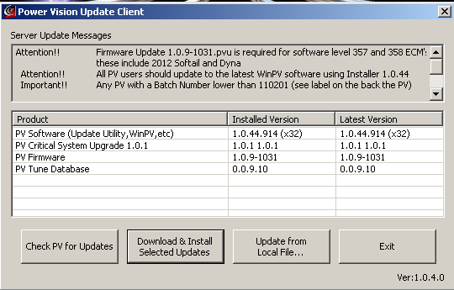
Latest versions as of 5/30/2012
2. Create a Value File. Open your calibration in the WinPV software and create a Power Vision value file under File/Save Selected Values that has the following tables: VE front, VE rear, AFR or Lambda fuel table, and Front and Rear Spark tables. Select the tables by clicking the check box beside each table as below and then go to File – Save Selected Values. Name the file and save under the value file subdirectory. I suggest naming your calibration, value files, etc with a sequential number on the end to make it easier to keep up with the current version. For example, save the Value file as 08-JKPT-001.pvv
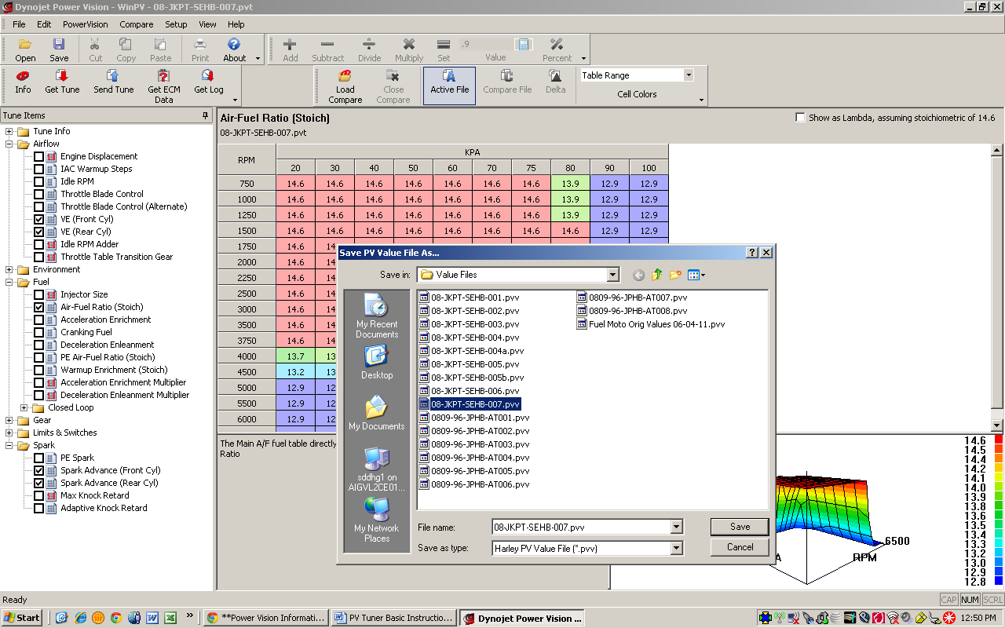
3. Setup Power Vision to collect data for Basic tune. Connect or Mount the Power Vision to your bike and power it up. Using the menus go to Datalog/Assign Signals and configure your Power Vision to datalog by adding the following channels:
• MAP (Manifold Absolute Pressure)*
• ET (Engine Temp)*
• Warm-up AFR or Lambda*
• TP (Throttle Position)*
• Engine Speed (RPM)*
• VE New Front*
• VE New Rear*
• Accel Enrich*
• Spark Knock Front*
• Spark Knock Rear*
• Desired Air/Fuel (Ratio)* or
Desired Air/Fuel (Lambda)*

Later versions of Log Tuner may also require:
• VE Front*
• VE Rear*

Add these if using autotune for both AFR and Lambda bikes/calibrations
• Lambda 1**
• Lambda 2 **
* From H-D data bus
** From Auto Tune (when equipped)
Note on whether to select AFR or Lambda - If your calibration has the base fuel table represented in AFR, then fuel related channels on the PV will need to include AFR in the name (not lambda). Same applies for bikes / calibrations that have the base fuel table represented as Lambda, you'll need to pick channels that include lambda in the name (not AFR).
A rule of thumb
· all throttle by cable bikes will be "AFR"
· all throttle by wire bikes will be “Lambda” (except 200,202,204,and 205 level calibrations…..these would be 2008 Touring Models only)

Another Note: It may be easier to delete all the ones that are there and then just add back the ones above. Also note that what is displayed when selecting these values may not match the description once selected. For example, ET = Engine Temp.
Yet Another Note: Autotune Data Logger can be used to setup for tuning
I wanted to let you know that the PV has a "cool" new feature called Autotune Datalogger. I have been testing and using this feature for some time and got permission from DynoJet to share this with you guys. It has worked well for me to help hit areas that I was missing before during my tuning runs.
*** A note of Caution here - please BE CAREFUL WATCHING THIS SCREEN WHILE RIDING ****
What does Autotune Datalogger do?
- Loads the current PVT that is on the ECM, and displays the VE tables' axii (with RPM capped to 6000).
- Displays RPM and either MAP or TPS depending on the type of calibration that’s flashed to the ECM
- Draws an X on the current cell.
- When you hit "start" it logs to a file (same as gauge screen) but with all the appropriate signals for Autotune.
- For each cell, increments a counter each time it is hit. This is not a counter as in "adaptive good to go here" just a sign that it's been hit.
- It always logs lambda1 and 2 even if no wideband present
The main benefit to me is it puts the PV in a state where it knows everything about what's going on, in terms of the tune, what you're trying to do, etc etc. No fumbling around assigning signals in the gauges.
How do you get to it?
With the PV connected to your bike and ignition and run switch on, from the main menu screen, select "Settings", then "Enter Code". On that screen enter pin 319245 and select Save. Once the screen comes up, you can press start log just like you do on the gauges screen to begin data logging.
With the PV mounted, you can see at a glance what "cells" you are hitting while riding. TP, RPM, log name, etc are also displayed but they are small...... You can also start the Datalogger and just drop in a saddlebag or pocket if that is what you are currently doing. It will setup all the signals you need and write to the log. Just remember to start and stop the log like you do with the gauge display.
4. Create a Datalog with the Power Vision. Using the menu go to Datalog/Gauges and select a gauge to display. I prefer the 6 gauge display. Configure the gauge by adding channels to be displayed while riding. Some good values to see would be TP – Throttle Position, ET – Engine Temp, Front VE, Rear VE, MAP and Desired AFR. Once the gauge is configured as you want it, start the bike and press “start log”. Ride the bike as normal, trying to vary the load and RPM as much as possible. As the PV is gathering data it will display the log name you are creating. I.E. log0001.csv and the size. The log size will grow as you ride. When the ride is complete, make sure to press “end log” before you shut the motor off.
5. Retrieve Logs that were created from the Power Vision. Connect the PV unit to the PC via a USB cable and start the WinPV software. Use the menu or click “Get Log” to retrieve your log(s) and save them to your computer. Note the name of the log because you will need it later.
6. Configure PV Log Tuner Software. Open PV Log Tuner software and click “Options”.
Set the following parameters:
Stoich Value 14.6
Minimum Hit Count 30
Minimum Engine Temp 185
Maximum Engine Temp 300 (note: In Log Tuner version 1.10, DJ chdg suggested max to 300)
Check the box “HD O2 sensors for correction”

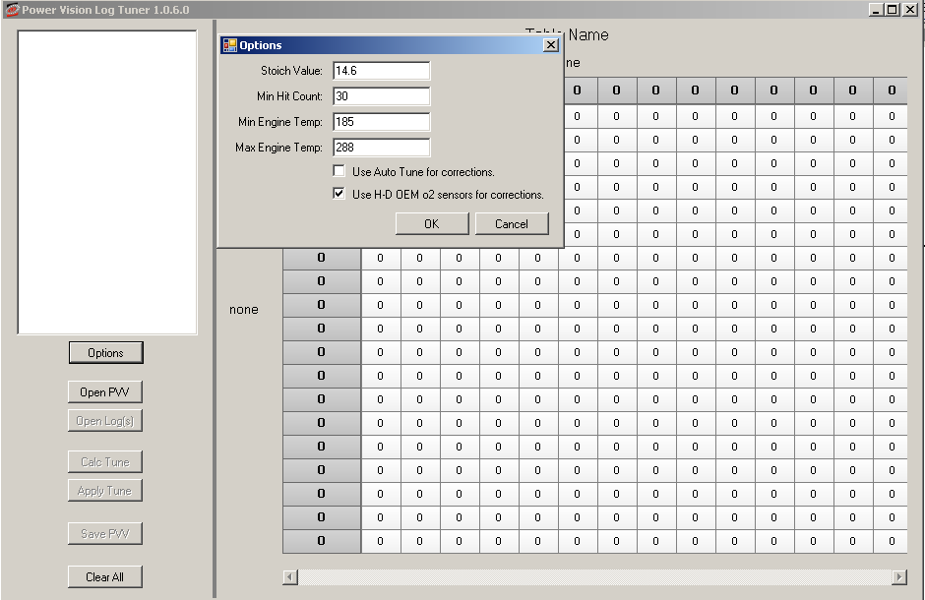
7. Import Value File. Click “Open PVV” and load the value file that was created in Step 2, I.E. 08-JKPT-001.pvv
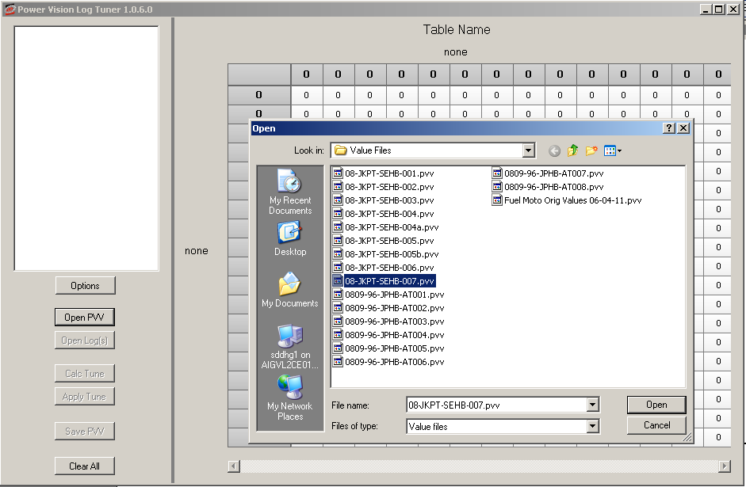
8. Import Logs. go to “Open Logs” and load the log files that were created in Step 4. You can load a single or multiple logs. You can select multiple logs to load by holding the Ctrl key when selecting.
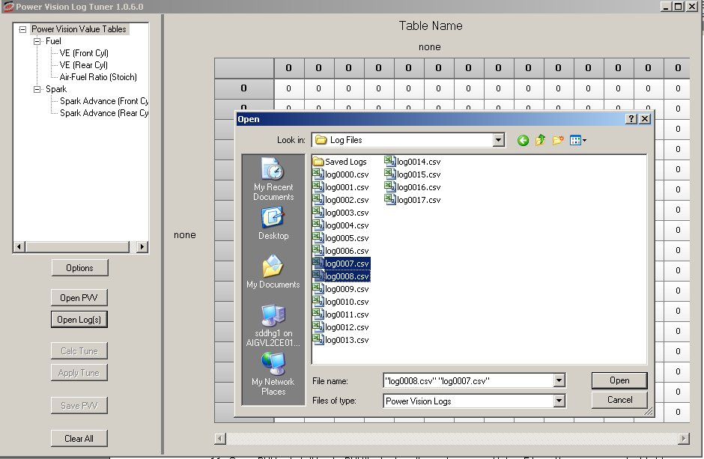
9. Calculate Tune. click “Calc Tune” which will calculate corrected VE values and Spark Tables for the conditions and events that were datalogged. You can click on the tree view to see each calculated table, hit count, VE Delta, etc.
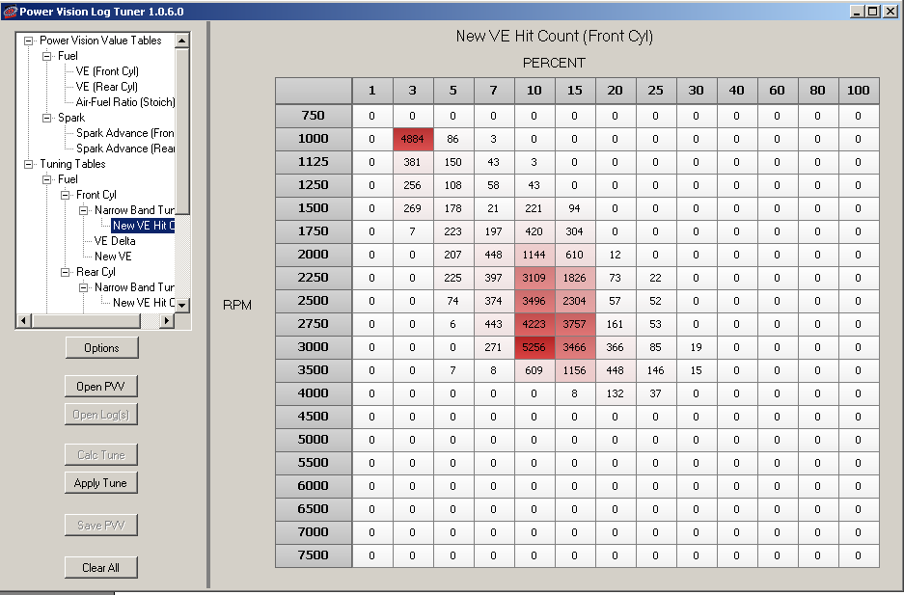
10. Apply Tune. click “Apply Tune” which will apply the new calculated VE/Spark values to the original Power Vision value file that was loaded in Step 7
11. Save PVV. click “Apply PVV” which will create a new Value File with your corrected tables, you will name this file and save it to your computer. I.E. 08-JKPT-002.pvv. You can increment the sequential number so you know this is the next version.
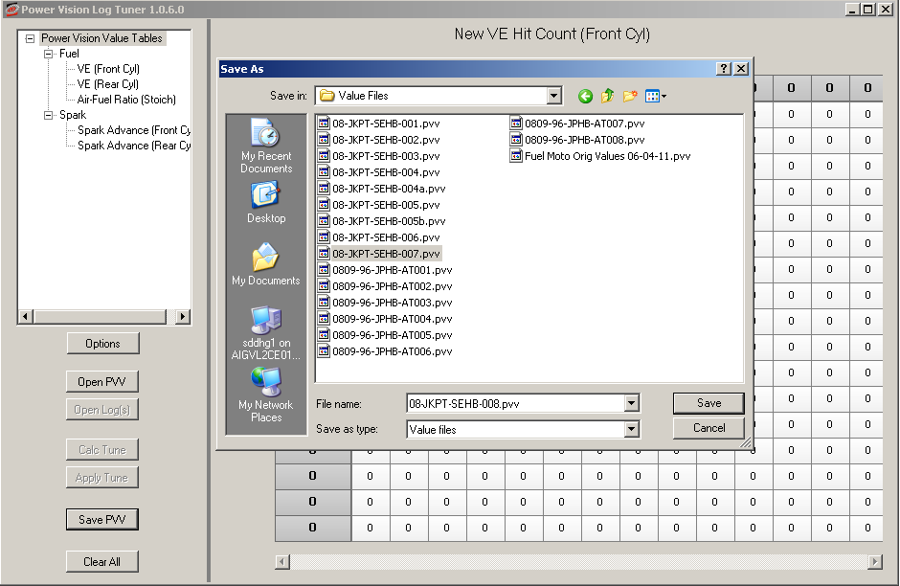
12. Import Value File. Switch back to WinPV and open your original calibration. Import the value file created from Step 11. Make sure your use the same calibration that was used while datalogging in step 4. To import the Value File, once you have opened your Power Vision calibration, go to File/Load All Values and select the PVV that you created and saved in step 11.

13. Save New Calibration. Now save this calibration by selecting, File, Save As. Name this calibration and increment the sequential number.
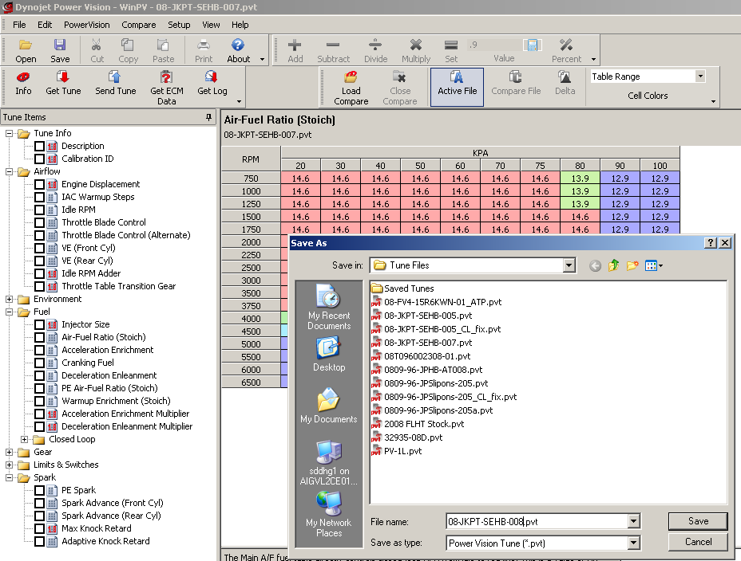
14. Send new tune to PV. With the PV still connected to the PC, once you have saved the calibration, click the Send Tune icon and send the new calibration to the PV. Select a slot to load the tune and press OK.

15. Reflash ECM. Now that you have an updated calibration, you can disconnect the PV from the PC and use the PV to flash the tune to your bike following the PV instructions.
Tips/Advanced options
Keep log sessions to 15-30 minute session, this keeps the logs a reasonable size and is generally ideal for collecting and sorting data
You must have a closed loop calibration to use Log Tuner Basic. To enable closed loop Lambda values must be between .977 and 1.02 or AFR must be 14.6.
Log Tuner Basic will populate approx 2/3 of the normal operating range of the VE tables using the standard Lambda/AFR table in most closed loop calibrations, and in most cases higher RPM/Load areas should be well within reasonable tune for a given combination. However more advanced users may choose to increase the area that PV Log Tuner Basic will populate by enlarging the closed loop area of the AFR/Lambda table. This is done by temporarily extending the Lambda/AFR values up to as high as 4000 RPM or more and 80Kpa.

It is recommended to first do some PV Log Tuner corrections with standard AFR/Lambda table and then if necessary extend the tables. This will allow you to gather additional data. Note if you choose extend the closed loop area it is also critical to monitor engine temp and spark knock events as you are setting up the calibration with a temporarily leaner than normal mixture in the higher load areas in order to gather data. As a general guideline you should also remove approx 4 degrees of spark timing as well. Also note if you choose to extend the closed loop range that when you are done logging and create your tune that you must return your AFR/Lambda table to the original desired settings to ensure a proper mixture.

Closed Loop Bias Table Usage
One other table to note if you plan to run Closed Loop is the Closed Loop Bias table. The actual AFR that is maintained in closed-loop mode is influenced by the Closed Loop Bias table. The closed loop bias table is used to adjust the closed loop AFR, typically to run the mixture a bit richer than the table value of 14.6 would indicate. Setting the value in this table to 450 mV will result in a closed loop AFR of 14.68; increasing the value will give a richer mixture and decreasing the value will give a leaner mixture. For example, Setting CLB to an offset of 645 mV will target a AFR of approximately 14.64. Normal range for setting the CLB table is 250 – 675. Don’t exceed 798 as this would exceed the operating range of the stock O2 sensors when running in closed loop mode.
Note: Lambda calibrations do not have a Closed Loop Bias table.

02 Sensor Voltage Table
Lambda | AFR | O2 mv |  | Lambda | AFR | O2 mv
0.969 | 14.22 | 801 |  | 0.985 | 14.46 | 775
0.970 | 14.24 | 799 |  | 0.986 | 14.47 | 773
0.971 | 14.25 | 798 |  | 0.987 | 14.49 | 771
0.972 | 14.27 | 796 |  | 0.988 | 14.50 | 768
0.973 | 14.28 | 795 |  | 0.989 | 14.52 | 764
0.974 | 14.30 | 794 |  | 0.990 | 14.53 | 761
0.975 | 14.31 | 793 |  | 0.991 | 14.55 | 758
0.976 | 14.33 | 792 |  | 0.992 | 14.56 | 756
0.977 | 14.34 | 791 |  | 0.993 | 14.58 | 750
0.978 | 14.36 | 789 |  | 0.994 | 14.59 | 746
0.979 | 14.37 | 788 |  | 0.995 | 14.61 | 741
0.980 | 14.39 | 786 |  | 0.996 | 14.62 | 730
0.981 | 14.40 | 785 |  | 0.997 | 14.64 | 645
0.982 | 14.42 | 783 |  | 0.998 | 14.65 | 580
0.983 | 14.43 | 780 |  | 0.999 | 14.67 | 515
0.984 | 14.45 | 778 |  | 1.000 | 14.68 | 450

Log Tuner Pro using DynoJet’s Autotune module requires you to take the AFR table out of closed loop. You should change the AFR table to some value other than 14.6 (Lambda 1). You can set it to something like 13.0 (.886) or 13.8 (.940). Also set Adaptive control to 0 to turn it off. After tuning with the Wideband sensors and setting the VEs, you can go back to running in closed loop. It is generally recommended to develop your tune with the AT module and WB sensors, and when you have it within a couple % you can reinstall your factory sensors and configure closed loop. It is also acceptable to setup a good open loop map and run that with adaptive control remaining disabled.
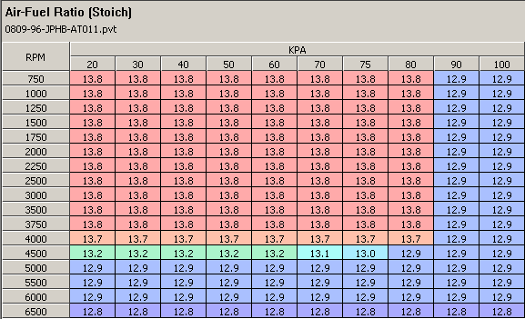

Another tip is to sequentially number your calibrations and make notes in the Description field of what you changed. That way you can go back if something doesn’t work and it is easier to keep up with all the changes you made.

How to setup your calibration for tuning

There are a couple of things you should do to your original calibration to improve the data logging process or setup the Calibration for tuning.

Start WinPV and open the calibration file you will use to do your tuning runs.
- Turn off PE Mode: Under Tune items Select > Limits & Switches > PE Enable RPM. Raise the PE Enable RPM limit above the current rev limiter. This will effectively disable Power Enrichment.
- You can set more of the AFR table to 14.6 to increase the areas that can be tuned by the stock O2 sensors. If you do this, pull at least 4 degress from the spark table to prevent detonation.
- Also for TBW bikes it is helpful to lower the idle RPM to hit some of the lower Throttle Position. You can safely lower the idle to 900.
- Also turn off Decel Enleanment and Accel Enrichment by setting the table values to zero during the tuning runs. This helps get a truer picture of what is going on for the VE tables.
- If you are tuning using the WB sensors, you should set the AFR table to a value other than 14.6. Set the table to something like 13.0 or 13.8.
- You should also set Adaptive control off by changing the value to zero.
- If you plan to use Adaptive control with the O2 Sensors after tuning, you can set the Closed Loop Bias table to make your closed loop a little richer. Set the CLB to either 700 or 750. That is still within the range of the stock O2 sensors and will richen up the closed loop range.
- Edit the description to indicate you have set this calibration up for tuning.
- You can save the calibration using a 3 digit suffix to the name to keep track of your versions. -000, -001, -002 etc.

Save the calibration with these changes, send to PV and flash to bike to do your tuning runs.

Repeat the tuning process until you see very little changes in the VE or spark Values. Once you are satisfied, return any parameters you changed in the calibration to the original values calibration and reflash the finished map to the bike. Naturally you would keep the VE tables and spark tables the way they are from the tuning runs. You could also adjust any other parameters that you want such as idle RPM, Decel Enleanment, Accel Enrichment etc.

Suggestions for tuning runs

Based on some forum questions, I thought about the “routine” I have been using during the tuning runs to hit more cells in the VE tables. Some of those areas are difficult to reach during normal riding. Hitting more areas improves your tune because as the ECM is calculating fuel delivery and the other factors involved, it takes into account not only the “cell” it is in as determined by Throttle Position/ MAP and RPM but the surrounding cells. To say it another way, I believe the grid version we see is just a representation of the data in tables and calculations going on in the ECM. Surrounding cells, before, after, above and below are taken into account when calculating fuel, spark, etc. Suffice it to say, the more areas of the VE and spark tables you get adjusted to match your bike’s configuration – The Better.

Here are some of the things I try to do during tuning runs. I have picked these up from reading tuning descriptions, other forums and tuning with some of the other products out there.

- Limit the tuning rides to 20 – 30 minutes. Try not to ride too aggressively. By setting up the calibration for tuning you have disabled some of the features that normally are active to protect your bike (AE, DE, PE, Etc.) You can cover a lot of areas in that time. Having some hills and a freeway nearby helps as well. Of course as a disclaimer, all of this should be done on a closed course.

- Find some hills and take them using slow throttle roll-on. Do this at a slow MPH in 3rd and 4th gear. This helps to hit lower RPM higher throttle position cells.

- During the run, be sure to include some decel datalogging. Instead of just releasing the throttle, slowly decrease Throttle position from lower and higher RPMS. This helps cover the MAP (Manifold Air Pressure) areas of the map lower that 30 kpa. Our bikes normally idle in the low to mid 30 kpa. During decel you will hit the 20kpa cells.

- Using slow throttle roll-on take 1st and 2nd gears into the upper RPMs. You can also do the same in 3rd gear but be careful of the speed. 3rd gear in upper RPMs can be quite fast.

- Be sure to ride some off highway speeds around 35-45 mph in 2nd, 5th and 6th gears.

- Ride some highway speeds in 3rd, 4th, 5th and maybe 6th gear. Be sure do some controlled acceleration like normal passing.

- Another thing to do is to start off and get moving in first gear, then shift to 3rd and gradually roll on the throttle. Let the bike slow down to around 1500 RPM and gradually accelerate in 3rd, 4th and 5th. Don’t lug the engine but this will help collect data in higher map cells at lower rpm.

- As you begin to finalize the tune after hitting as many areas as possible, be sure to ride like you normally do. I have found that it is best to make sure your normal riding area is as accurate as possible. Some people spend a lot of time at say, Wide Open Throttle or higher RPMS – but we rarely ride our bikes there and when we do it is only for a short period of time. One the last couple of runs, concentrate on normal riding to get those cells correct.
Suggestions for getting rid of decel popping

Once you are satisfied with your tuning runs and the VEs are set correctly, some folks still end up with some popping during decel. Some pipes seem more susceptible to the problem than others and I believe with some pipes you can just hear it better. Either way, some folks like the sound of decel popping and some don’t. I don’t, so here are some suggestions to get rid of it.

Decel popping is caused by unburnt fuel igniting in the exhaust. For the unburnt fuel to ignite, the “mix” in the exhaust must be in a certain range. To remove the decel popping, we need to upset that mix. Normally, decel popping can be cured by richening up the mixture during the decel event. Less frequently, you may need to lean the mixture. I will describe the process to enrich the mix. If this process makes the popping worse, then go the other way with the adjustments.

First, identify where the popping is occurring. If you are getting a decel pop when you let off on the throttle that quickly goes away, most likely it can be eliminated by making an adjustment to the Decel enleanment table of the map. To enrich the map during initial decel, go to the decel enleanment table and reduce the values up to 30%. Reducing enleanment, enriches the mix. Yes, I know that sounds weird! You can start by reducing 10%, then increment by 5% up to a total of 30% to see if it gets rid if the pop when shifting or when you let off the throttle. This table only affects the decel event for a short period of time.

Here is an example of the table reduced by 30%.

Before 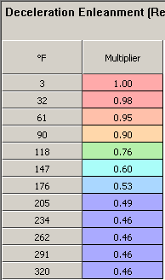 After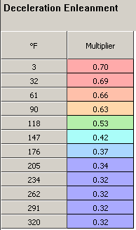

If that doesn’t correct the popping or if you get popping that lasts longer thru the decel event, then we need to make a change to the AFR table. Let’s say you get continuous popping from approximately 2750 RPM down thru 1800 RPM or so while decelerating. That example seems pretty common. If that is the case, we will lower the AFR in the 20KPa column to enrich the mix during the entire decel event. When you bike is decelerating, the MAP goes lower than 30KPa and you hit the 20KPa column of the map. You can adjust the AFR values in this column to remove the popping in the RPM range you are having trouble with.

Start by reducing, the AFR by 1 or so in the 20KPa column like this.

Before
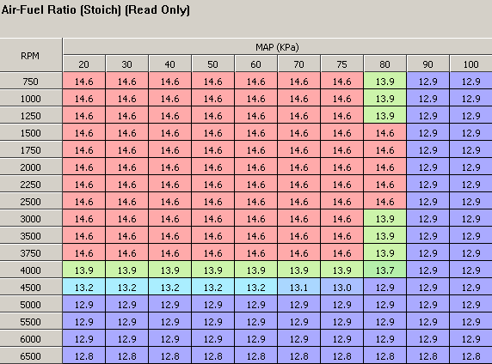

After
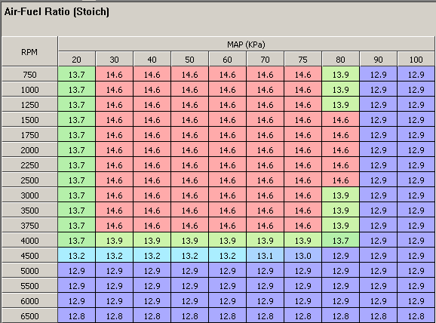

If after reducing the entire 20 KPa column, you still get some popping in the 2750 down thru 1800 RPM range, you can adjust the 20 KPa column like this example. This is actually what my AFR table looks like on my 2008 FLHT TBW.

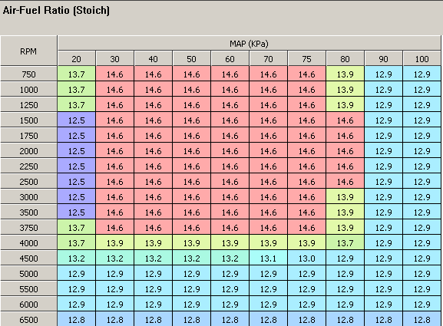

Ride and Enjoy.

JustDennis (on hdforums.com)
__________________

